“NEWS EXPLORER”

A Project Report Submitted in the partial fulfillment of the requirements for the award of the degree of

BACHELOR OF TECHNOLOGY

in

DEPARTMENT OF COMPUTER SCIENCE ENGINEERING

by

S.Anusha :2520030158

M.Srinikitha :2520030161

D.Deekshitha :2520030216

Under the Guidance of

Dr. V.Sireesha
Professor
Department of Computer Science and Engineering





2026-27

DEPARTMENT OF COMPUTER SCIENCE ENGINEERING

Declaration

The Project Report entitled “NEWS EXPLORER” is a record of Bonafide work of SAGILI ANUSHA– 2520030158, MOTHE SRINIKITHA – 2520030161, DATRIKA DEEKSHITHA – 2520030216 submitted in partial fulfillment for the award of B. Tech in Computer Science and Engineering. The results embodied in this report have not been copied from any other departments/University/Institute.

S>ANUSHA– 2520030158
M.Srinikitha – 2520030161
D.Deekshitha – 2520030216

DEPARTMENT OF COMPUTER SCIENCE ENGINEERING

CERTIFICATE

This is certify that the mini project based report entitled “NEWS EXPLORER” is a bonafide work done and submitted by SAGILI ANUSHA – 2520030158, MOTHE SRINIKITHA– 2520030161, DATRIKA DEEKSHITHA – 2520030216 in partial fulfillment of the requirements for the award of the degree of BACHELOR OF TECHNOLOGY in Department of Computer Science Engineering, during the academic year 2026-27.

Signature of the Guide Signature of the HOD
(Dr. V.Sireesha)
ACKNOWLEDGEMENT

Description in Times New Roman font 12 size with two to three paragraphs thanking guide Dr. V.Sireesha , Professor, Dept. of CSE and Dr. P. Venkateswara Rao, Associate Professor, HOD CSE

SAGILI ANUSHA – 2520030158
MOTHE SRINIKITHA – 2520030161
DATRIKA DEEKSHITHA – 2520030216

Abstract

In today’s digital world, people rely on various online platforms to stay updated with current events and news from different fields. However, finding relevant, reliable, and up-to-date news across multiple sources can be time-consuming. To address this problem, our project focuses on the Design and Development of News Explorer, a user-friendly web application that provides a centralized platform for discovering and exploring news articles.

The platform allows users to browse the latest news, explore different categories, search for specific topics, and access relevant news information through an attractive and responsive interface. The system is designed to simplify news discovery by organizing information in an accessible format, enabling users to find articles of interest quickly and efficiently. It aims to improve the overall reading experience by reducing the effort required to navigate multiple news websites.

The application is developed using modern web technologies, with an emphasis on usability, responsive design, and efficient information retrieval. In conclusion, News Explorer provides a convenient digital solution for accessing and exploring news from different categories in one place, helping users stay informed about current events through a simple and engaging interface.

Table of Contents

 |  |  | Page No.
 | Acknowledgement
 | Abstract
 | Table of Contents
 | List of Figures
1 | Introduction | 1.1 Overview  1.2 Problem statement  1.3 Scope of the project  1.4 Objectives | 5-15
2 | System Requirements | 2.1 Functional Requirements  2.2 Non-Functional Requirements | 16-21
3 | System Design | 3.1 High-level Architecture Diagram  3.2 Description of each layer | 33-36
4 | Implementation | 4.1 Module-wise implementation  4.2 Front-end logic (UI rendering, state management)  4.3 API integration  4.4 ……. | 38-47
5 | Results |  | 56-64
6 | Challenges & Limitations | 6.1 Issues faced during development  6.2 Solutions applied  6.3 Limitations of the System | 74-82
7 | Conclusion & Future Work | 7.1 Conclusion  7.2 Future Work  7.3 Skills learned during development | 89-97
 | References | - Books, tutorials, APIs, documentation sites used | 98-99

List of Figures

1.1 Block Diagram of a Recommendation System 3
1.2 Components of a Recommendation System 6
1.3 Flow Chart to show the working of a Recommendation System 7
1.4 Phases of a Recommendation System 8
1.5 User-User KNN based Recommendation System 13
1.6 Item-Item KNN based Recommendation System 14
1.7 Matrix Factorization based Recommendation System 40

- INTRODUCTION

1.1 Overview
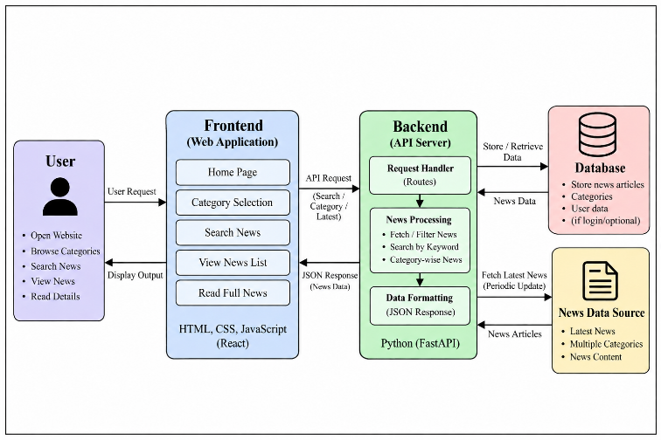

Fig. 1.1 Architecture of Cloud
1.2 Problem Statement
In the modern digital world, a large amount of news is published daily across various websites and online platforms. Finding relevant and up-to-date news on specific topics can be time-consuming because users often need to visit multiple websites and navigate through large amounts of information. Additionally, difficulty in searching for particular news articles and exploring different news categories can reduce the overall user experience.
The main problem addressed by News Explorer is the lack of a simple and convenient platform for discovering and accessing news from different categories in one place. The project aims to develop a user-friendly web application that enables users to browse the latest news, search for specific topics, explore different categories, and access relevant articles through an organized interface. The proposed system focuses on simplifying news discovery, improving accessibility, and providing a smooth and efficient user experience.

1.3 Scope of the Project
- Browse the bundled sample headlines and read an article by topic.
- Search article content using KMP, Z-function, and Rabin–Karp demonstrations.
- Perform approximate title matching using Levenshtein and Damerau–Levenshtein edit distance.
- Demonstrate multi-pattern search with Aho–Corasick.
- Explore repeated phrases through suffix arrays and LCP arrays.
- Compare article content using Jaccard similarity and an educational MinHash signature.
- Run demonstrations for dynamic programming, network flow, matching, approximation, randomized algorithms, and parallel primitives.
- Use a numbered console menu, query router, complexity guide, and self-check.

1.4 Objectives
- Develop a single Java application that organizes news-themed examples through numbered choices.
- Provide a local sample corpus for repeatable algorithm demonstrations.
- Implement selected string-search and approximate-matching algorithms.
- Demonstrate advanced algorithm topics through runnable examples and explanatory output.
- Keep the project self-contained without third-party library dependencies.
- Document the implemented behavior and clearly state conceptual previews and limitations.

2. SYSTEM REQUIREMENTS

2.1 Functional Requirements
FR-01 — Display menu: Show numbered options for the application's user-facing features.
FR-02 — Browse articles: List sample headlines and display article title, category, reading-time estimate, metadata, and content.
FR-03 — Topic browsing: Allow users to select a topic and then select a listed article.
FR-04 — Phrase search: Search the local corpus using the implemented string-search routines.
FR-05 — Approximate matching: Show close title matches using edit-distance calculations.
FR-06 — Multi-pattern search: Demonstrate matching of multiple patterns using Aho–Corasick.
FR-07 — Repeated phrase analysis: Build a suffix array and LCP array for a selected text.
FR-08 — Similarity demonstration: Compare selected article content using Jaccard similarity and MinHash-style signatures.
FR-09 — Advanced algorithm demos: Provide menu-accessible examples for dynamic programming, network flow, matching, approximation, randomized algorithms, and parallel operations.
FR-10 — Query router and diagnostics: Provide a local menu-driven query router, complexity guide, and self-check.

2.2 Non-Functional Requirements
Usability: Numbered menu choices reduce the need to type commands or phrases manually.
Portability: The program can run on systems with JDK 8 or later.
Maintainability: The main implementation is organized in one Java source file, with explanatory Markdown documents in docs/.
Dependency simplicity: The application uses Java standard I/O and does not require third-party libraries.
Repeatability: Bundled sample data allows the same educational examples to be run without downloading a dataset.
Clarity: The menu uses user-facing feature names, while the documentation maps those features to the underlying algorithms.

2.3 Software and Hardware Requirements
Language/runtime: Java; JDK 8 or later.
Source file: src/NewsExplorer.java.
Editor: Visual Studio Code or another Java-capable editor (optional).
Execution: Command Prompt, PowerShell, or a terminal.
Dependencies: No third-party dependencies are required.
Network: The bundled corpus and documented offline reader do not require network access.
Hardware: A standard computer capable of running a Java runtime.

Compile from the NewsExplorerFinal project directory using: javac -encoding UTF-8 -d out src\NewsExplorer.java. Run using: java -cp out NewsExplorer.

3. SYSTEM DESIGN

3.1 High-Level Architecture
Input: User selects a numbered menu option or query-router choice.
Application logic: NewsExplorer.java dispatches the selected operation to the corresponding method.
Local data: The program loads 18 bundled sample articles into an Article array and uses custom data structures for algorithm demonstrations.
Output: Console output displays article details, search results, similarity/graph/DP examples, complexity information, or self-check results.

Figure 3.1: High-level architecture of News Explorer

3.2 Module Description

3.2.1 News Corpus and Article Browsing
The Article structure stores fields such as article ID, title, category, content, views, estimated reading time, and relevance. loadCorpus() adds the bundled sample entries to an in-memory Article array. The browsing feature lists headlines and prints the selected article's information. The sample corpus contains 18 entries and includes Telugu-script examples.

3.2.2 String-Processing Module
This module contains KMP, the Z-function, double-modular Rabin–Karp, edit-distance routines, Aho–Corasick, suffix-array construction, and LCP computation. The functions operate on strings from the local corpus or on demonstration inputs selected through the menu.

3.2.3 Dynamic-Programming Module
The dynamic-programming demonstrations include Levenshtein, Damerau–Levenshtein and weighted edit distance; global and local sequence alignment; matrix-chain multiplication; optimal binary search tree; bitmask TSP; Hamiltonian-path detection; tree-related DP examples; and sum-over-subsets (SOS) DP.

3.2.4 Graph and Network-Flow Module
The graph demonstrations use custom graph and edge structures. Implemented examples include Dinic maximum flow, Edmonds–Karp, residual reachability for minimum cut, bipartite matching by augmenting paths, and a min-cost max-flow demonstration. The citation-flow example uses a synthetic capacity network; it is not based on a real citation database.

3.2.5 Approximation, Randomized, and Parallel Module
The program demonstrates vertex-cover approximation, greedy set cover, subset-sum DP, list scheduling, randomized quicksort, Miller–Rabin primality testing, reservoir sampling, universal hashing, parallel reduction, and prefix-scan concepts. Runtime measurements for parallel operations depend on the machine and JVM environment.

3.3 Program Flow
- The program starts and initializes the bundled article corpus.
- The main menu prints the available user-facing features.
- The user selects a numbered option.
- The selected menu handler reads any additional numbered choices required for the demonstration.
- The relevant article data or algorithm routine is executed.
- The program prints results and returns to the menu unless the user selects Exit.

3.4 Data Design
The program stores articles in an Article array with space for up to 24 entries. The loadCorpus() method currently adds 18 sample articles. Each record contains an ID, title, category, content, view count, estimated reading time, and relevance value. These records are created in the source code, not saved in a database. The algorithms use arrays and custom data structures for their demonstrations.

4. IMPLEMENTATION

4.1 Menu and Article Browsing
The main menu has 17 numbered options and an Exit option. The choices cover headline browsing, topic-based browsing, phrase search, exact-phrase search, fuzzy search, multi-pattern search, repeated-phrase analysis, article similarity, algorithm demonstrations, story connections, a query router, a complexity guide, and a self-check. The names shown in the menu are written for users; the underlying algorithms are described in this report.
The source maps the options to the following main operations: option 1 lists headlines; option 2 browses by topic; options 3 and 4 run phrase search using different matching methods; option 5 runs fuzzy search; option 6 searches several patterns; option 7 explores suffix-array/LCP output; option 8 compares articles; options 9–14 open the DP, flow, matching, complexity, randomized/parallel, and citation-flow demonstrations; option 15 opens the local query router; option 16 prints the complexity guide; and option 17 runs the self-check.
Choice-based navigation uses numbered choices for topics, articles, phrases, and selected demonstrations. The offline news reader displays bundled sample text in the terminal. The content is educational and should not be described as verified current reporting.

4.2 String Algorithms

4.2.1 Knuth–Morris–Pratt (KMP)
KMP preprocesses a search pattern into a longest-prefix-suffix (LPS) array. During matching, the LPS values help the algorithm continue from a useful pattern position after a mismatch. The implementation uses buildLps() and kmp().

4.2.2 Z-Function
The Z-function computes how many characters at each string position match the prefix of that string. zFunction() builds the Z-array, and zSearch() combines the pattern and text to locate a match.

4.2.3 Rabin–Karp
Rabin–Karp compares rolling hash values for text windows and the search pattern. The implementation uses two modular hash values and verifies candidate matches with a direct region comparison to guard against collisions.

4.2.4 Approximate Matching
The application includes Levenshtein and Damerau–Levenshtein edit-distance methods. These calculate the minimum edit operations needed to transform one string into another, with Damerau–Levenshtein also considering adjacent transposition. The fuzzy-search feature uses edit distance to list close title matches.

4.2.5 Aho–Corasick
Aho–Corasick uses a trie and failure links to search for multiple patterns in one text scan. The project includes an educational ASCII-folded implementation and reports whether any of the selected patterns matched.

4.2.6 Suffix Array and LCP
The suffix-array implementation sorts suffixes using prefix doubling and merge sort, with O(n log² n) time under the documented implementation. The LCP array is computed using the Kasai-style approach. SA-IS, suffix automata, and suffix trees are conceptual previews and are not claimed as fully implemented builders.

4.3 Dynamic Programming
The dynamic-programming demonstrations cover string edit distance and sequence alignment, interval DP for matrix-chain multiplication and optimal BST, bitmask DP for TSP and Hamiltonian-path detection, tree-related calculations, and SOS DP. Some menu options use fixed educational examples rather than a persistent user-specific reading profile.

4.4 Network Flow and Matching
The graph module defines custom flow edges and residual capacities. It implements Dinic and Edmonds–Karp maximum-flow methods, residual reachability for min-cut, augmenting-path bipartite matching, and a min-cost max-flow demonstration. The project-selection and citation-flow examples use synthetic data for algorithm learning.

4.5 Approximation, Randomized, and Parallel Algorithms
Approximation examples include vertex cover, greedy set cover, and list scheduling. Randomized and number-theoretic examples include randomized quicksort, Miller–Rabin primality testing, reservoir sampling, and universal hashing. Parallel demonstrations use Java threads for reduction and prefix-scan concepts. These are educational demonstrations; the scheduling example is an approximation and the parallel timings are environment-dependent.

4.6 Query Router and Performance Guide
The TextHack query router is a local, menu-driven dispatcher that routes a selected query to search, fuzzy matching, similarity, story connections, scheduling, or primality demonstrations. It is an API-style console interface, not an HTTP server or a public web API. The performance guide reports algorithmic complexity information, and the self-check runs representative demonstrations.

4.7 Implementation Boundaries
The submitted source uses Java standard I/O and custom structures, and it does not require third-party libraries. The application operates on the bundled local corpus. The source does not establish a live-news RSS/API connection, database persistence, a browser interface, or a backend web service. These should be treated as future extensions, not existing features.

5. RESULTS

5.1 Implemented Features
The source code and accompanying project guide document a menu-driven console application with local article browsing, several text-search methods, approximate matching, repeated-phrase analysis, similarity comparison, a query router, complexity information, and demonstrations of advanced algorithm topics.
News browsing: Lists local sample headlines and displays selected article details.
String search: Includes KMP, Z-function, Rabin–Karp, and Aho–Corasick demonstrations.
Approximate search: Calculates edit distances and lists close title matches.
Repeated phrases: Constructs suffix arrays and LCP arrays.
Similarity: Demonstrates Jaccard similarity and seeded MinHash signatures.
Advanced algorithms: Includes dynamic programming, network flow, matching, approximation, randomized algorithms, and parallel primitives.
Diagnostics: Includes a complexity guide and a complete self-check option.

5.2 Sample Test Cases
TC-01 — Compile the Java source with the documented javac command.. Expected observation: The source compiles without errors in a compatible JDK.
TC-02 — Run the application and choose option 1.. Expected observation: The sample headlines are listed.
TC-03 — Choose option 2 and select a topic and article.. Expected observation: The chosen bundled article is printed in the console.
TC-04 — Choose phrase-search options.. Expected observation: Matching behavior is demonstrated against the local corpus.
TC-05 — Choose fuzzy search.. Expected observation: Close title matches and edit-distance output are displayed.
TC-06 — Choose repeated-phrase analysis.. Expected observation: Suffix-array/LCP output is displayed for the selected text.
TC-07 — Choose the complexity guide or full self-check.. Expected observation: Complexity information or representative diagnostic output is printed.

Use these cases to test the final program before submission. Mark each one as Pass or Fail after running it; the expected results listed here are not a substitute for actual test execution.

6. CHALLENGES AND LIMITATIONS

6.1 Development Challenges
Combining algorithms from several syllabus areas in one application creates a challenge in keeping the menu accessible while retaining technically meaningful demonstrations. String matching, dynamic programming, graph algorithms, approximation, randomized methods, and parallel operations each require different data structures and output formats.
A second challenge is ensuring that educational sample data is not mistaken for live news. The project uses locally embedded sample articles, including language-technology examples, so the program can be demonstrated without relying on an external data source.

6.2 Solutions Applied
- Organized the main program around numbered, user-facing menu options.
- Stored article metadata and content in a common Article structure.
- Used custom arrays, queues, sorting, and graph structures for algorithm demonstrations.
- Grouped algorithm functionality into menu features that communicate the user-facing purpose.
- Added project documentation describing the syllabus mapping, feature mapping, choice-based navigation, and offline reader.
- Identified conceptual previews separately from fully implemented algorithms.

6.3 Limitations of the System
- The corpus contains 18 bundled educational sample documents, not a large real-world news dataset.
- The sample headlines and article text are not verified current news.
- The program is a Java console application rather than a graphical web application.
- The README contains a section describing live RSS news, but the submitted Java source and OFFLINE_NEWS_READER.md describe option 2 as offline-only and the source contains no RSS/network retrieval. This report follows the executable source and offline-reader guide: the current program uses bundled sample content. Confirm this discrepancy with the team before submission.
- The query router is not an HTTP server or public API.
- The application does not use a database or persistent user accounts.
- SA-IS, suffix automata, and suffix trees are conceptual previews rather than complete implementations.
- MinHash is an educational signature approximation, not a production locality-sensitive hashing index.
- The scheduling demonstration is approximate, and parallel timing depends on the runtime environment.
- The citation-flow example uses synthetic capacities rather than real citation data.

7. CONCLUSION AND FUTURE WORK

7.1 Conclusion
News Explorer is a Java console project that combines a news-themed local corpus with practical demonstrations of algorithms. It provides article browsing and search-oriented menu options while demonstrating string algorithms, dynamic programming, network flow, matching, approximation, randomized algorithms, and parallel computation. The implementation uses Java standard I/O and custom data structures, and it can run without third-party dependencies.
News Explorer is an educational project, not a full news service. Its 18 articles are examples, and the current Java source does not provide a live news feed, database, browser interface, or public HTTP API.

7.2 Future Work
- Expand the local corpus using properly licensed and documented text data.
- Add a real news feed only after selecting an appropriate provider and implementing network handling, attribution, and error cases.
- Separate the single Java source file into modules if maintainability becomes a priority.
- Add automated test cases with known expected results for each algorithm demonstration.
- Improve input validation and error handling for boundary cases.
- Add a graphical interface or web front end as a separate extension without describing it as part of the current console version.
- Benchmark algorithms using a documented dataset and repeatable environment, where performance evaluation is required.

7.3 Skills Learned During Development
- Java programming and console-based menu design.
- String matching, edit-distance algorithms, suffix arrays, and LCP computation.
- Dynamic programming and sequence alignment.
- Graph representation, maximum flow, minimum cut, and bipartite matching.
- Approximation algorithms, randomized algorithms, hashing, and primality testing.
- Basic parallel reduction and prefix-scan concepts.
- Algorithm complexity analysis and documenting implementation limitations.

REFERENCES
[1] Oracle, “Java Documentation,” https://docs.oracle.com/en/java/
[2] Oracle, “Java Platform, Standard Edition API Specification,” https://docs.oracle.com/en/java/javase/
[3] J. H. Morris, Jr. and V. R. Pratt, “A Linear Pattern-Matching Algorithm,” Technical Report 40, University of California, Berkeley, 1970.
[4] R. M. Karp and M. O. Rabin, “Efficient randomized pattern-matching algorithms,” IBM Journal of Research and Development, vol. 31, no. 2, pp. 249–260, 1987.
[5] D. E. Knuth, J. H. Morris, Jr., and V. R. Pratt, “Fast Pattern Matching in Strings,” SIAM Journal on Computing, vol. 6, no. 2, pp. 323–350, 1977.
[6] C. D. Manning, P. Raghavan, and H. Schütze, Introduction to Information Retrieval. Cambridge University Press, 2008. https://nlp.stanford.edu/IR-book/
[7] News Explorer project source: src/NewsExplorer.java.
[8] News Explorer project documentation: README.md, docs/FEATURE_GUIDE.md, docs/SYLLABUS_MAPPING.md, docs/CHOICE_BASED_NAVIGATION.md, and docs/OFFLINE_NEWS_READER.md.
Keep only references actually consulted by the team and follow the citation style required by the department.

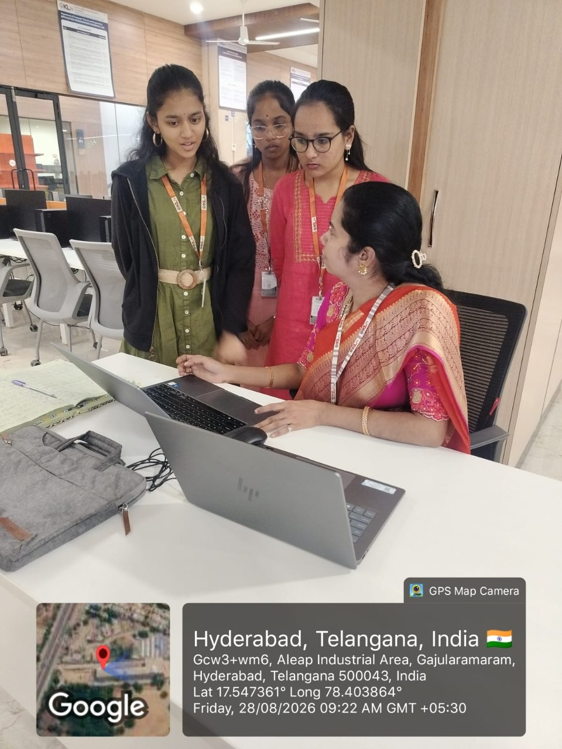




REFERENCES
- R. Buyya et al., “Cloud computing and emerging IT platforms: Vision, hype, and reality for delivering computing as the 5th utility,” Future Generation Computer Systems, vol. 25, no. 6, pp. 599–616, 2009.
- F. Tao et al., “CLPS-GA: A hybrid genetic algorithm for energy-aware cloud service scheduling,” Appl. Soft Comput., vol. 19, pp. 264–279, 2014.
- https://azure.microsoft.com/en-us/resources/cloud-computing-dictionary/what-is-cloud-architecture

[

